Abstract title

F1. FamName1ª, F2. FamName2^{b}, F3. FamName3ª, F4. FamName4ª

ªDepartment, Address, Institution, Country
^{b}Department, Address, Institution, Country

The abstract should be prepared using 10 pt Times New Roman fonts and 9 pt Times New Roman for the caption and references. Abstracts should be written in English and submitted in docx/doc-format.
The length of each abstract is strictly limited to one page. Abstracts should be in B5 (JIS) format (182 mm × 257 mm). All text and ﬁgures have to ﬁt with inside margins of 2.5 cm (left, right, top and bottom).
The title should be typed in 12 pt Times New Roman and left aligned. If necessary, use a second line, single-spaced just below the ﬁrst. Leave one line before the names of the authors (10 pt Times New Roman) and again before the single-spaced affiliations and addresses (9 pt Times New Roman, italics). After leaving one line, the body text is typed in one-column format. The text should be 10 Times New Roman fonts, single spaced. If you chose to submit color-ﬁgures, remember, that the printed Book of Abstracts will be in black and white. References in the text should be indicated using numbers in brackets [1], [2]. Please, do not use page numbering, section break or page break in your abstract!
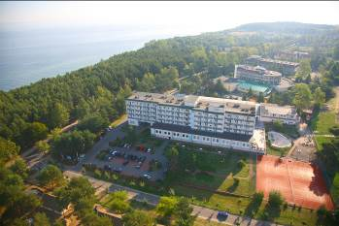
Fig. 1 The ASTOR HOTEL in Jastrzębia Góra, the venue of the symposium
The representatives of the member societies are asked to collect the one-page abstracts of the contributions with the indication of the required mode of presentations, and send them in bulk to the contact e-mail address by 30 April, 2022. One registered participant can only submit two contributions at maximum.

Acknowledgements: We thank National Science Foundation for….(Times New Roman 9 pts)

References
[1] F1. Name1, F2. Name2, Journal volume (year) page.
[2] F1. Name1, F2. Name2, F3. Name3, F4. Name4, Journal volume (year) page.

Please name your abstract as:

section-number_author1_type-of-presentation_id-number.doc or docx

where:
- section-number – according to the topics of the symposium,
- author1 – first author’s name ,
- type-of-presentation – keynote, oral, poster,
- id-number – use number if submit more than one abstract.

e.g. 1_ryczkowski_poster_1.doc

